**Exp.2 Design an LED Chaser**

**Circuit Diagram**

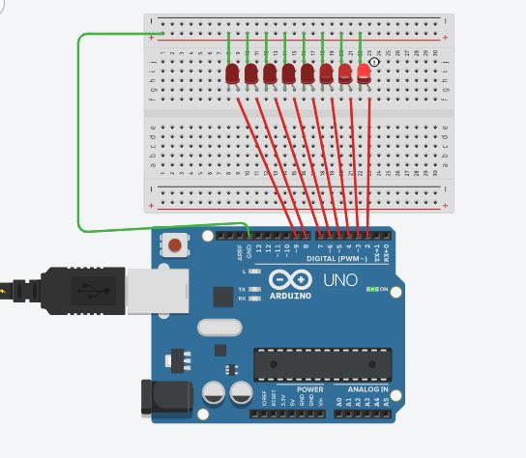

Theory

Concepts Used:

We use the basic concepts in this experiment which are listed as below:

1. Parallel circuit
2. Basic insights of the Arduino Uno digital input/output pins.
3. How to obtain the effects of chaser lights via code on genuine ide.
4. Making of circuits using in breadboard.

Learning and Observations

In this experiment we learnt the following as the experiment comes to about completion:

1. Modifying the code will never get you to the effect you wanted.
2. There is no concept of delay after the line of LOW.

In this experiment we observe the following things:

1. The LEDs glow in sequential manner means when the first led is OFF then at the same time second LED will turn ON and this process will continue till the last LED and again first LED will glow and this process will continue.
2. The LEDs makes a pattern in this experiment.

Precautions

These points should be kept in the mind while making the circuit:

1. Always ensure the positive terminal of the LEDs is connected to the output pin of the Arduino Uno.
2. Before uploading the code to the Arduino Uno (microcontroller) check the port and board under the tools menu.
3. Always ensure that the circuit you have made is the correct before uploading the code to Arduino to avoid any type of anomalies.
4. Always ensure that the connections are tightly. There should not be any loose connections between the port and the Arduino and Arduino and the breadboard.
5. Always check the LEDs is working or not before connecting to the circuit with the help of multimeter.

Learning Outcomes

We learn from this experiment while performing is illustrated as follows:

1. Understand how the breadboard works in parallel circuit.
2. How the current flows in the breadboard.
3. Increased understanding of the code used in Arduino IDE.
4. How we can use the loop for the repetition process.
5. We can make our own LED dancing circuit just by improving the circuit.